1. Mount the sandbox to S: drive: run the script Mount_S_Drive.bat found in Scripts\VirtualDrive\core
2. Check setup_env.bat found in S:\Tools\Build_Env\Workspace\Build and remove the proxy if you are connected to the vpn(not in Autoliv’s offices)

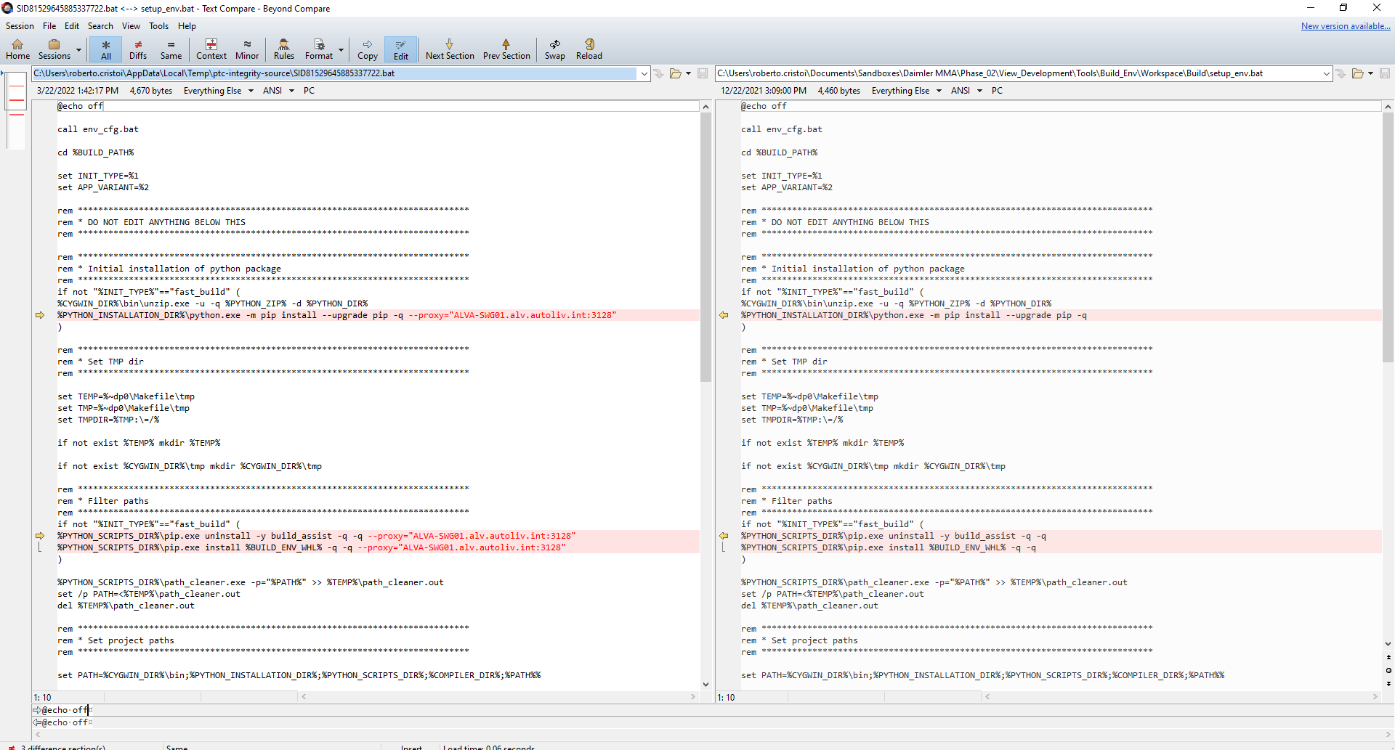

Left side: on site

Right side: remote

1. Run setup_env.bat and way until the window closes
2. Check if the compiler has been extracted: S:\Tools\Tasking\Installation\TASKING_TriCore_v6.3r1p2
3. Go to S:\Tools\Build_Env\Workspace\Build and open “build_window” shortcut. It shall look like this:

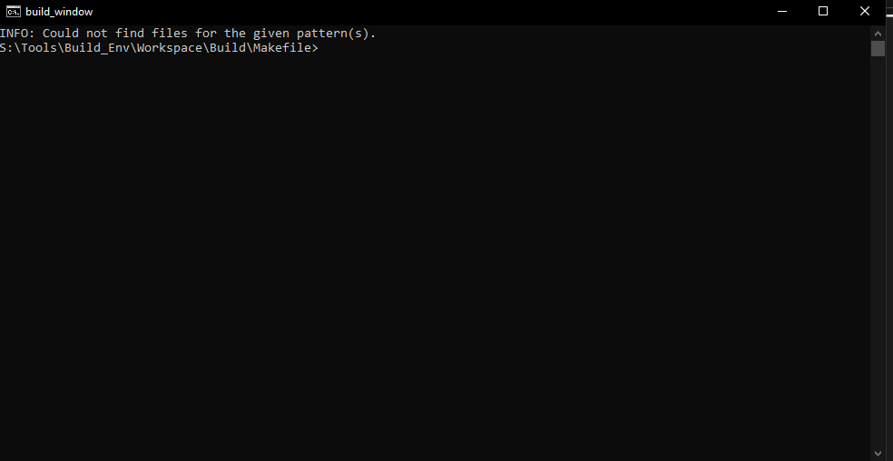

1. To build any target all you have to do is to write **make target**, e.g: make app, make fbl, make bm, make fbl_upd, make hsm, make hsm_upd
2. To clean the build folder use **make target-clean**, e.g: make app-clean
3. Build results can be found in S:\Tools\Build_Env\Workspace\Outputs\target\Out
4. Compilation and linker errors will be displayed in the console but for more info you shall look into S:\Tools\Build_Env\Workspace\Outputs\target\Err